**PROJECT REPORT**

**FOR**

**LIBRARY MANAGEMENT SYSTEM**

**BY**

**MUHAMMAD ABDUL RAFAY**

**Library Management System**

**Introduction:**

Introduction to the Learning Management System Project:

Our project aims to develop a comprehensive Library Management System (LMS) that caters to the needs of students and administrators in managing and accessing educational resources. The LMS provides a user-friendly interface with features such as user registration, login, book viewing, and administration capabilities for managing books. For students, the LMS offers a seamless experience to explore and access a wide range of educational materials. Upon registration, students can create their accounts, providing them with personalized access to the system. The login functionality allows students to securely access their accounts and retrieve their information from anywhere and at any time.Once logged in, students can search for books using different criteria such as title, author, or category. They can view detailed information about each book, including its description, availability status, and related resources. Students also have the option to save books to their personal reading list or mark them as favorites for future reference.The LMS facilitates efficient book management by providing an intuitive interface for administrators. Admins can access advanced functionalities like adding new books to the system, updating existing book details, and removing outdated or unavailable books. The admin dashboard offers a centralized view of all book records, enabling quick and convenient management.

For better tracking and reporting, the LMS maintains comprehensive records of student activities, including book borrowing history, due dates, and return status. These records help administrators monitor the utilization of resources and generate reports for analysis, assisting in informed decision-making and resource planning.The project also prioritizes security measures to protect user data and system integrity. User authentication and authorization mechanisms are implemented to ensure secure access and prevent unauthorized access to sensitive information.Overall, our Learning Management System project aims to enhance the learning experience by providing an efficient platform for students to access educational resources and for administrators to manage the library effectively. It promotes seamless communication, facilitates resource tracking, and offers a user-friendly interface for all users involved.

**Requirements and Specifications:**

* **2.1 Functional Requirements:**

**1. Manage Books:**

* Add a new book to the system, including details such as title, author, category, and availability status.
* Update existing book details, such as title, author, category, and availability status.
* Delete a book from the system.

**2. Manage Students:**

* Add a new student to the system, including details such as name, email, and student ID.
* Update existing student records, including name, email, and other relevant information.
* Delete a student record from the system.

**3. Issue Book:**

* Allow an authorized user to issue a book to a student.
* Record the issuance details, including the student's information, book details, and the issuance date.

**4. Login:**

* Provide a secure login functionality for users to access their accounts**.**

**5. Sign Up:**

* Allow new users to create an account by providing necessary details like name, email, and password**.**

**6. Return Book:**

* Enable users to return a book that they have borrowed.
* Update the book's availability status and the return date.

**7. View Book:**

* Display a list of books available in the system.
* Show detailed information about a selected book, including title, author, category, availability status, and related resources.

**8. Add Book:**

* Allow authorized users to add new books to the system.
* Collect necessary book details, including title, author, category, and availability status

**9. Update Book:**

* + Enable authorized users to update the details of an existing book.
  + Modify information such as title, author, category, and availability status.

**10. Delete Book:**

* + Allow authorized users to delete a book from the system.
  + Remove all associated records and resources related to the deleted book.

**11. Update Student Record:**

* + Enable authorized users to update the details of a student's record.
  + Modify information such as name, email, and other relevant information.

**12. Delete Student Record:**

* + Allow authorized users to delete a student's record from the system.
  + Remove all associated records and resources related to the deleted student.

**13. View Issued Books:**

* + Display a list of books that are currently issued to students.
  + Show relevant details such as the student's information, book details, and the issuance date

**14. View Defaulter List:**

* + Generate a report or list of students who have not returned books within the specified due date.
* **2.2 Non-Functional Requirements:**

1. **Security:**
   * The system should ensure the confidentiality and integrity of user data.
   * User authentication should be implemented securely to prevent unauthorized access.
   * Measures should be taken to protect against common security threats such as SQL injection and cross-site scripting.

**2. Performance:**

* + The system should provide fast response times for user interactions.
  + The application should be able to handle a reasonable number of concurrent users without significant slowdowns.
  + Database operations should be optimized for efficient data retrieval and storage.

**3. Usability:**

* + The user interface should be intuitive and easy to navigate.
  + User actions and system responses should be clear and understandable.
  + The system should provide helpful error messages and validation to guide users.

**4. Reliability:**

* + The system should be stable and reliable, minimizing system failures or crashes.
  + Data integrity should be maintained, and proper backup mechanisms should be in place to prevent data loss.

**5. Scalability:**

* + The system should be able to accommodate an increasing number of users and books without major performance degradation.
  + The architecture should support scalability to handle future growth and additional features.

**6. Compatibility:**

* + The system should be compatible with popular operating systems.
  + It should be responsive and provide a consistent user experience across different devices and screen sizes.

**7. Maintainability:**

* + The codebase should be well-structured and modular to facilitate future maintenance and updates.
  + Code documentation should be provided for easy understanding and modification.
  + Best practices and coding standards should be followed to ensure code quality and readability.These simplified non-functional requirements highlight the key aspects that need to be considered to ensure a secure, high-performing, user-friendly, reliable, scalable, compatible, and maintainable Learning Management System.

**System Design:**

* **3.1 Overall Architecture:**

The LMS system follows a client-server architecture. The client side is developed using Java Swing for the front-end interface, allowing users to interact with the system. The server side utilizes Java for business logic implementation and connects to the SQL database for data storage and retrieval.

DFD Library management system 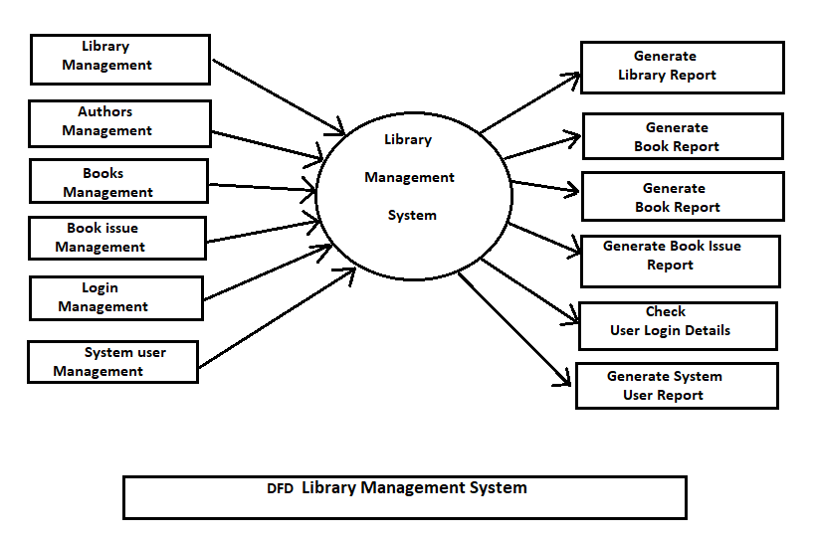

**Implementation:**

* **4.1 Technologies:**

The following technologies, programming languages, and frameworks were utilized to create the Library Management System (LMS):

The Library Management System (LMS) utilizes the following technologies, programming languages, and frameworks:

**1. Programming Languages:**

Core Java: The core functionality of the system is implemented using the Java programming language, which provides robustness and platform independence.

SQL: Structured Query Language (SQL) is used for database management and data retrieval.

**2. Database Management System:**

MySQL: The LMS utilizes MySQL as the database management system to store and manage book information, student records, and other relevant data.

**3. Java Frameworks and Libraries:**

Java Swing: The graphical user interface (GUI) of the LMS is developed using Java Swing, which provides a rich set of components for creating interactive desktop applications.

JDBC: Java Database Connectivity (JDBC) is used for connecting to the MySQL database, executing queries, and retrieving data.

**4. Integrated Development Environment (IDE):**

NeatBean: The NeatBeans Apache is used for Java development, providing a comprehensive set of tools for coding, debugging, and project management.

**4.3 challenges or issues encountered**

During the development process, some common challenges encountered in the Library Management System include database design, data validation, concurrency, performance optimization, security, and error handling. These challenges were addressed by conducting thorough analysis for efficient database schema, implementing data validation mechanisms locking to ensure data consistency, optimizing query performance, implementing secure coding practices, and implementing structured error handling and logging mechanisms.

**5. System Features and Functionality:**

The LMS system encompasses the following major features:

**User Account Management:**

**Function:** This feature allows users to create new accounts, log in to the system, and reset their passwords if needed.

How it functions: Users can register by providing their information, such as name, email, and password. The system securely stores user credentials and allows registered users to log in using their email and password. In case of a forgotten password, users can initiate a password reset process, which may involve email verification or security questions.

**Book Management:**

**Function:** This feature enables librarians to manage the library's book collection, including adding new books, updating book information, and deleting books.

How it functions: Librarians can input book details, such as title, author, ISBN, category, and availability status, into the system. The information is stored in the database, allowing librarians to easily search, update, and remove book records. The system may include features such as barcode scanning or ISBN lookup to streamline the process.

**Book Issuing and Returning:**

**Function:** This feature facilitates the borrowing and returning of books by library users.

How it functions: Users can search for available books, check their availability status, and request to borrow them. Librarians can process the borrowing request, update the book's status as "issued," and associate it with the borrowing user. When the user returns the book, the librarian updates its status as "available" and removes the association with the user. This feature helps track book circulation and ensures the availability of books for other users.

**Student Management:**

**Function:** This feature allows librarians to manage student information, including adding new students, updating their details, and deleting student records.

How it functions: Librarians can input student details, such as name, student ID, contact information, and membership status, into the system. The information is stored in the database, enabling librarians to maintain accurate student records. This feature aids in student identification, communication, and managing membership privileges.

**Reporting and Analytics:**

**Function:** This feature provides comprehensive reporting and analytics capabilities to monitor library operations and generate insights.

How it functions: The system generates reports on various aspects, such as book inventory, borrowing history, fine records, and overdue books. Administrators and librarians can access these reports to gain insights into library usage, identify popular books, track overdue items, and make data-driven decisions for resource allocation and collection management.

These major features of the Library Management System collectively support efficient library operations, streamline book management, simplify user interactions, and provide valuable insights for decision-making and resource optimization.

**Conclusion and Future Work:**

In conclusion, the Library Management System (LMS) is a comprehensive software solution designed to efficiently manage books, students, and their interactions within a library environment. By leveraging technologies such as Java, MySQL, Java Swing, and XAMPP, the LMS offers a user-friendly interface, robust security measures, and optimal performance. The system allows users to perform various functions, including signing up and logging in, viewing and searching books, issuing and returning books, managing student records, and administering the library's collection. These functionalities are supported by a well-designed database schema and data modeling, ensuring data integrity, efficient retrieval, and scalability.The non-functional requirements of the LMS have also been carefully considered. Security measures are implemented to protect user data, performance optimizations ensure fast response times, and usability features make the system intuitive and easy to navigate. Reliability is prioritized through stability measures and regular backups, and scalability is achieved by designing the system to handle increasing volumes of data and users.The LMS project demonstrates the successful integration of technologies, adherence to best practices, and consideration of both functional and non-functional requirements. By incorporating these elements, the LMS provides a robust and efficient solution for library management, enhancing the overall user experience and facilitating effective library operations.

**ScreenShot Of Project:**

* **SIGNUP PAGE**

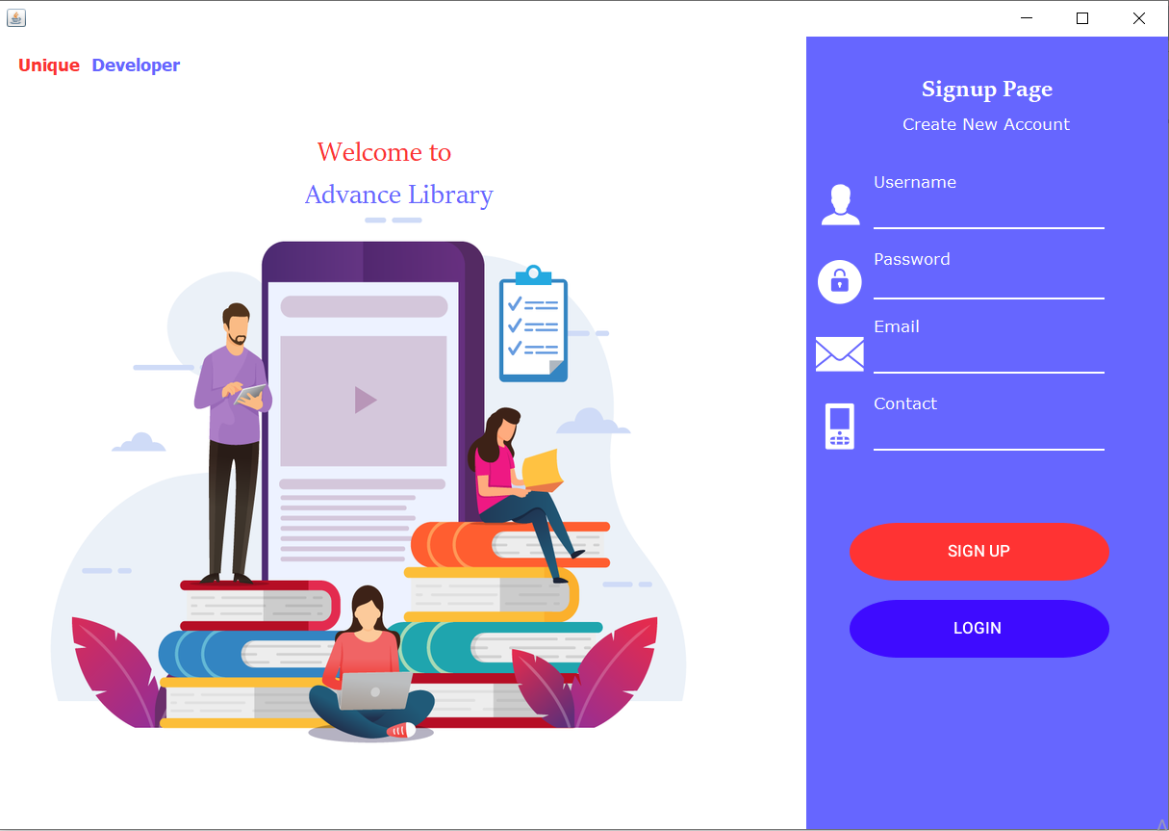

* **LOGIN PAGE**

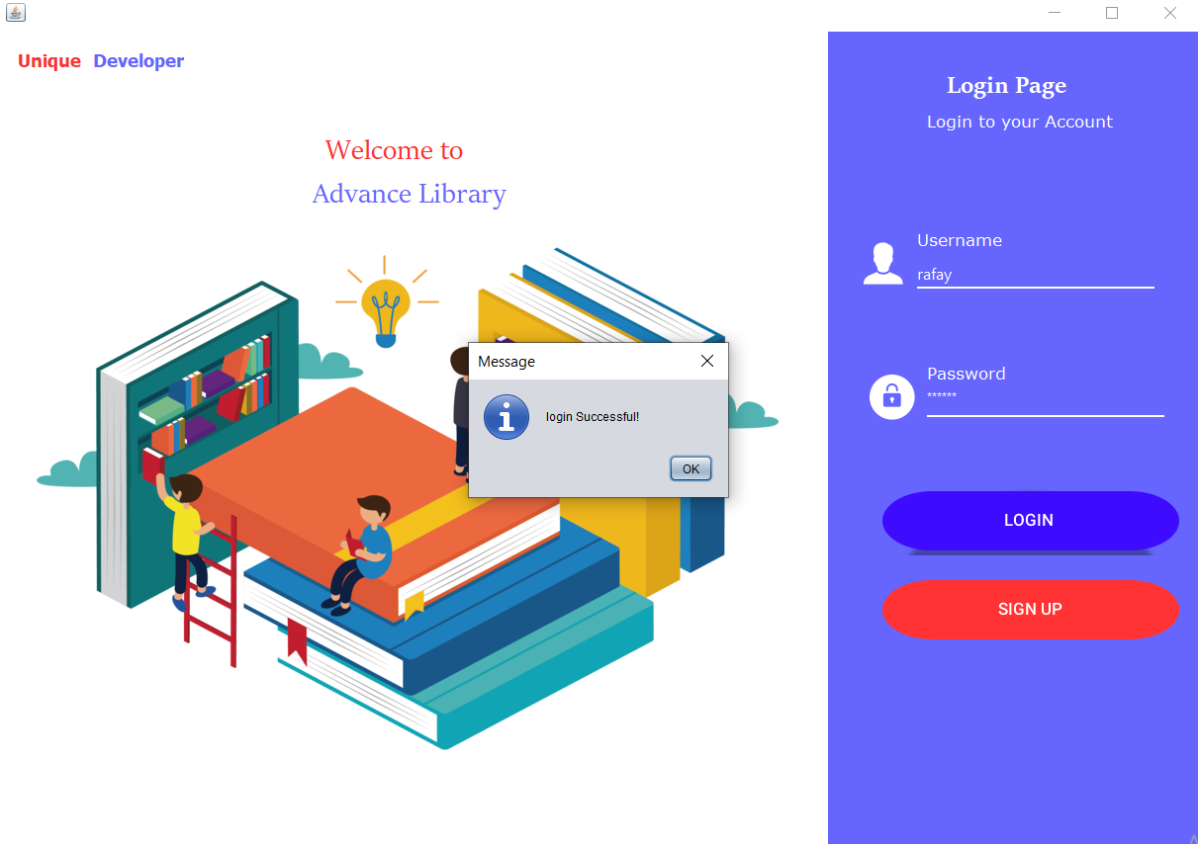

* **HOMEPAGE**

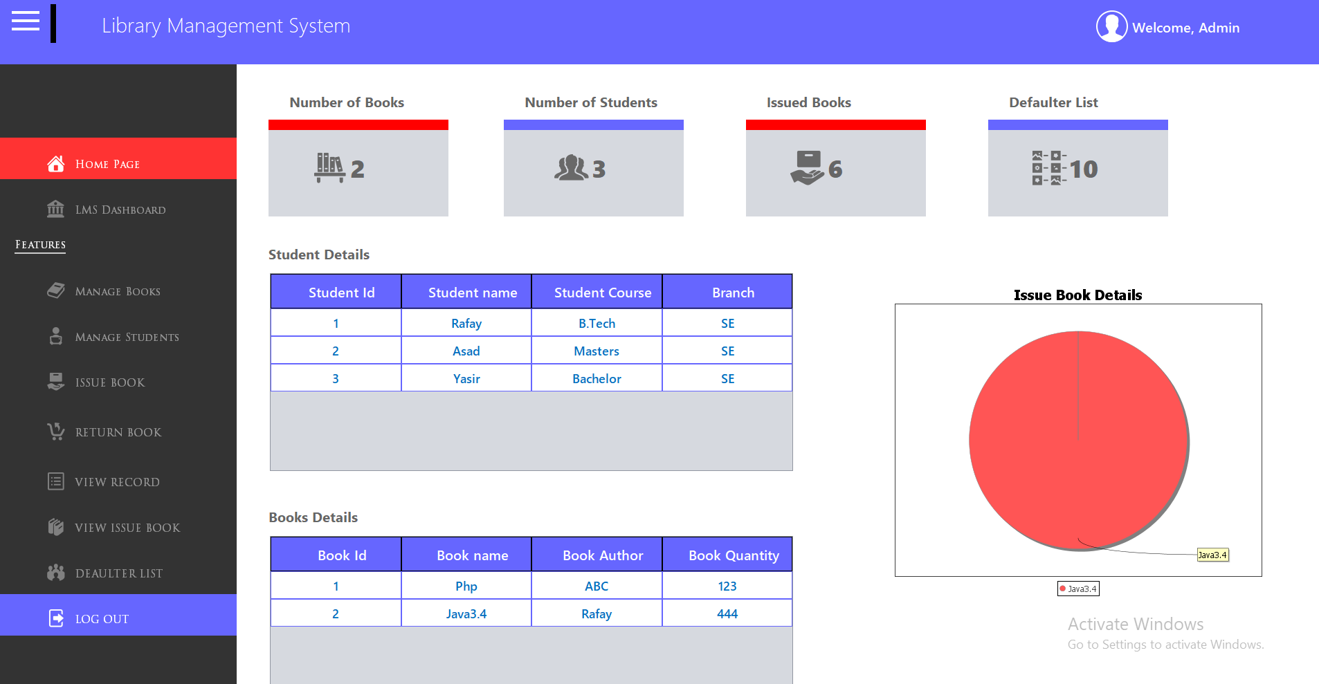

* **MANAGES THE BOOKS**

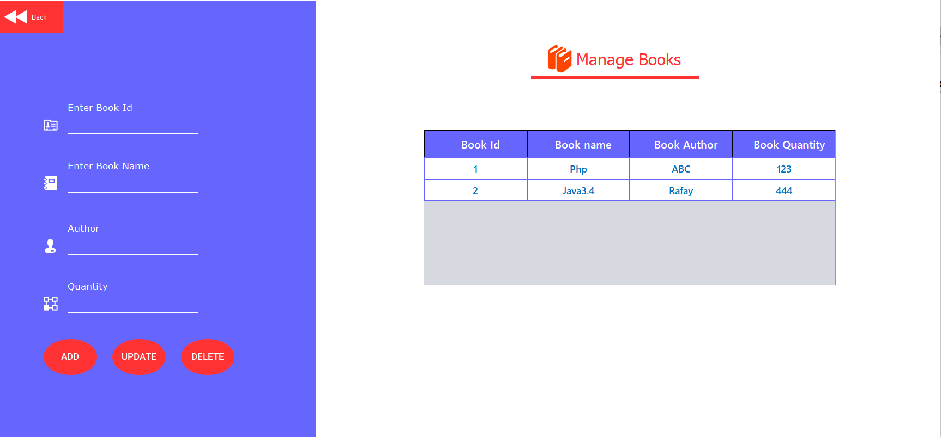

* **MANAGE STUDENTS**

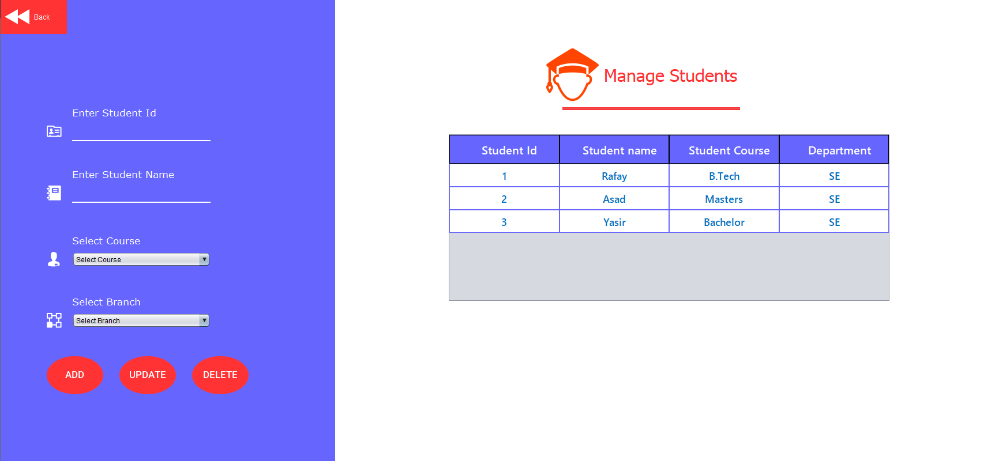

* **ISSUE BOOK DETAILS:**
* Which book is issued to which student

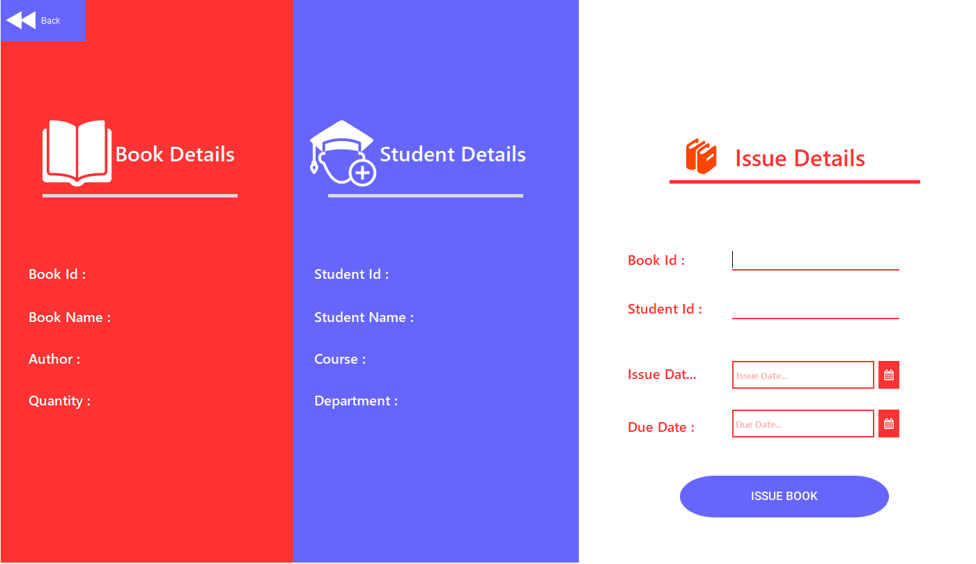

* **User can Return the Book**

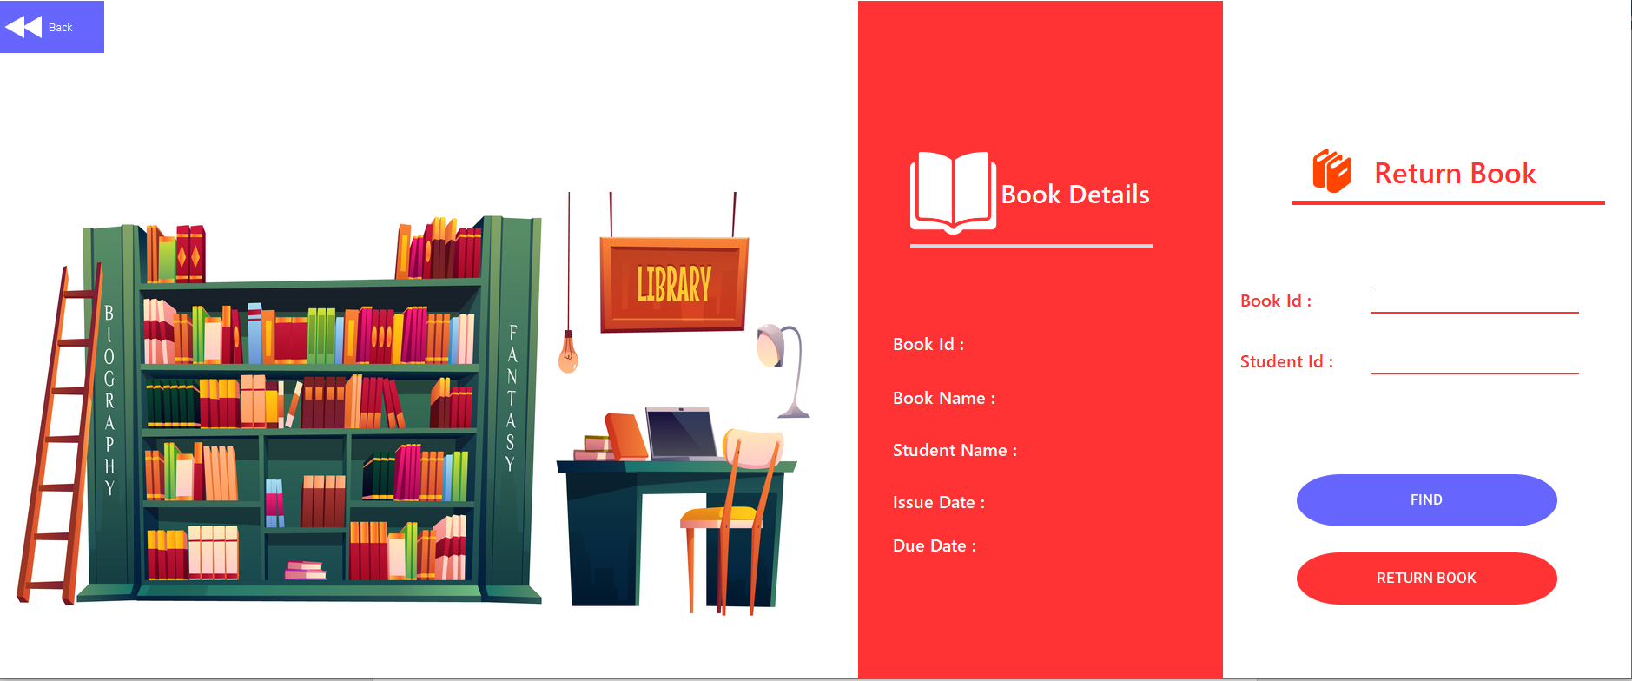

* **VIEW RECORDS**

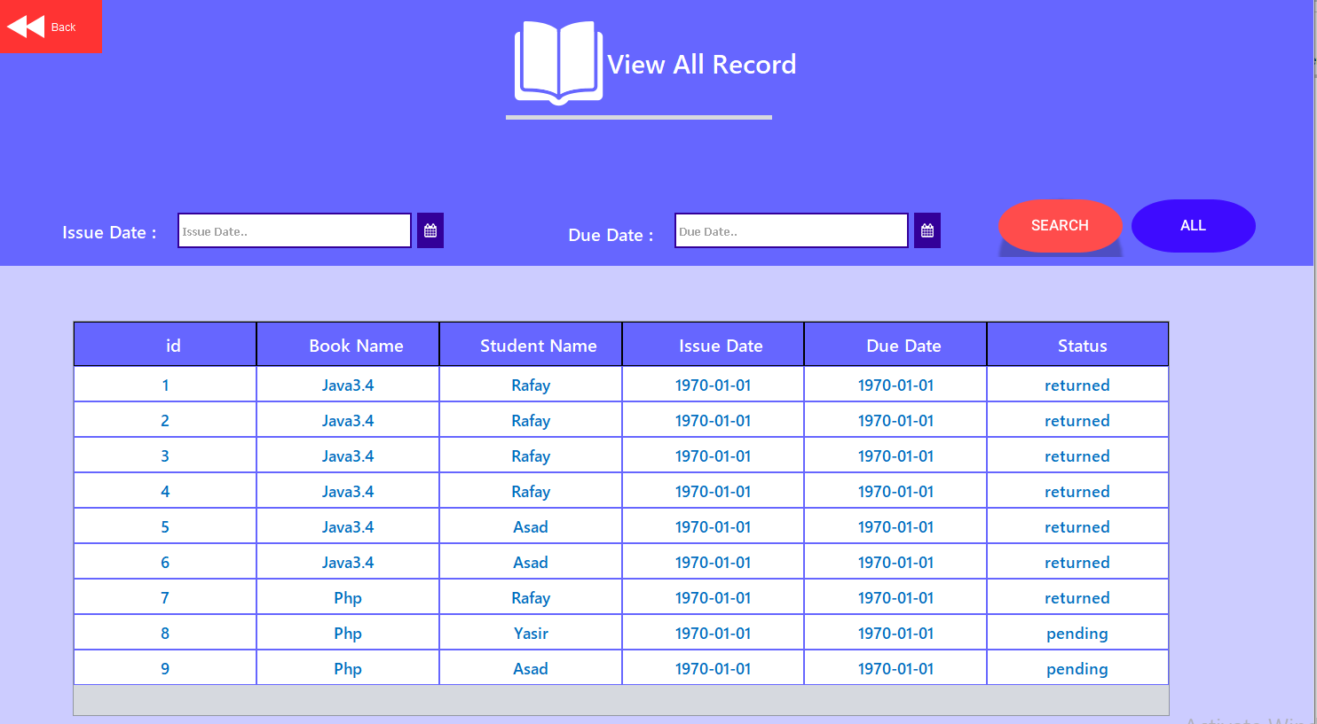

* **THE ISSUE BOOK DETAILS**

